EMPLOYEE RAISE ISSUE – RECORD PRODUCER & SERVICE PORTAL INTEGRATION
PHASE 6: Creating Widgets and Adding Them to the Page

1. Introduction
This phase enhances the Service Portal by creating a custom informational widget and placing widgets on the Employee Center portal page. HTML and CSS are used to create an interactive visual experience.

2. Objective
To create the Commercial Widget, preview it, and add the required widgets to the portal page.

3. Creating the Commercial Widget
1. Navigate to Service Portal Configuration → Widget Editor.
2. Click Create a new widget.
3. Set Widget Name to Commercial Widget.
4. Click Submit.
5. Enable the HTML and CSS templates.
6. Paste the HTML and CSS code from the project configuration.
7. Click Save.
8. Enable Preview to verify the design.
Widget Editor – Commercial Widget
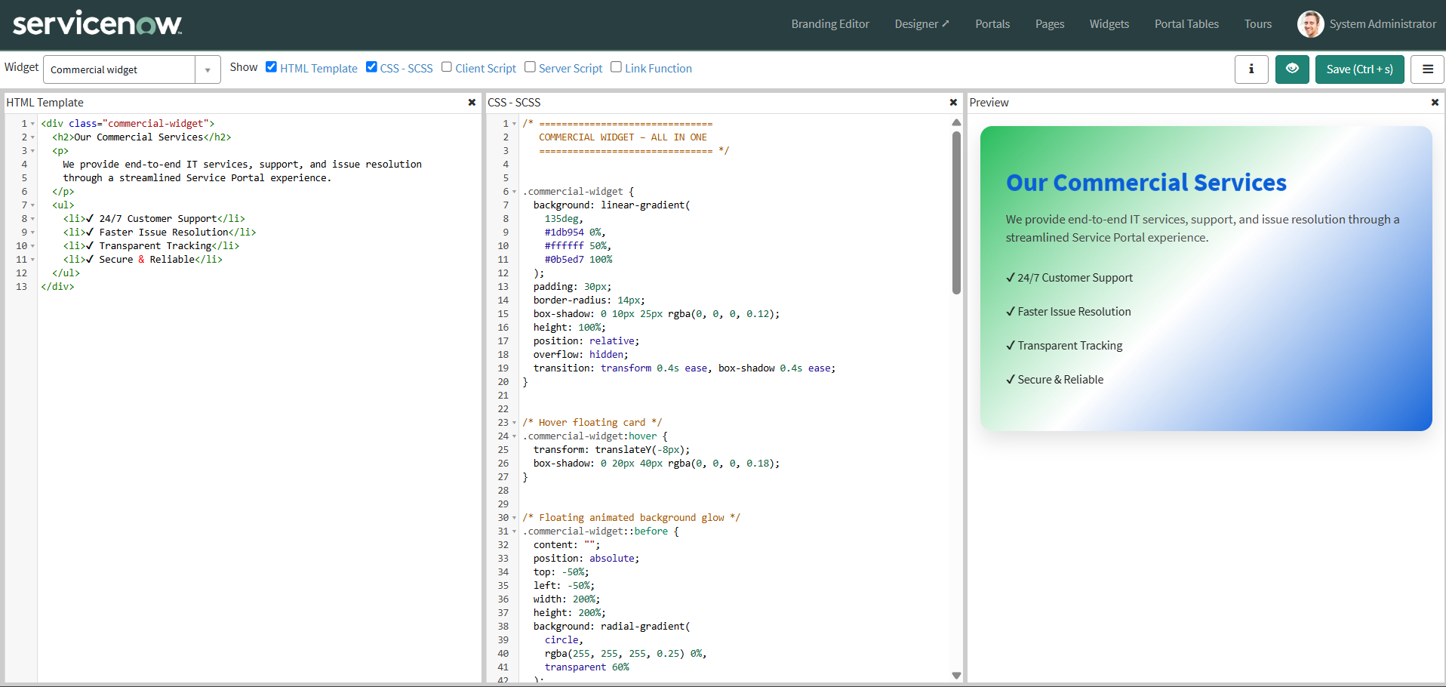
HTML/CSS templates with widget preview enabled
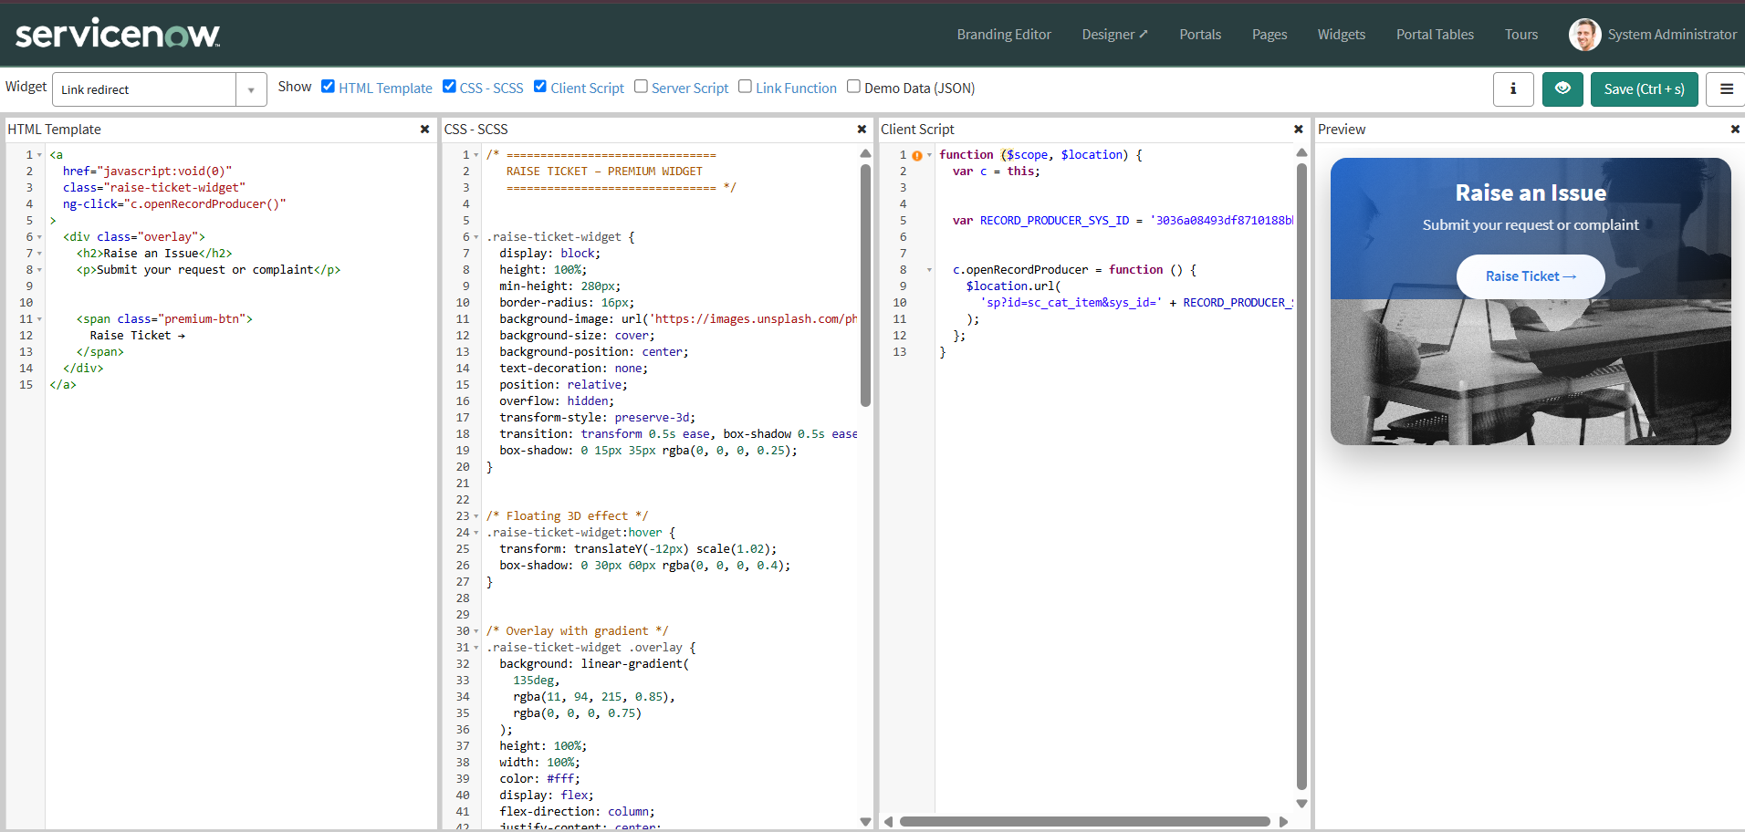

4. HTML Code
<div class="commercial-widget">
<h2>Our Commercial Services</h2>
<p>We provide end-to-end IT services, support, and issue resolution through a streamlined Service Portal experience.</p>
<ul>
<li>✔ 24/7 Customer Support</li>
<li>✔ Faster Issue Resolution</li>
<li>✔ Transparent Tracking</li>
<li>✔ Secure & Reliable</li>
</ul>
</div>

5. CSS Code
.commercial-widget {
background: linear-gradient(135deg, #1db954 0%, #ffffff 50%, #0b5ed7 100%);
padding: 30px;
border-radius: 14px;
box-shadow: 0 10px 25px rgba(0,0,0,0.12);
height: 100%;
position: relative;
overflow: hidden;
transition: transform 0.4s ease, box-shadow 0.4s ease;
}
.commercial-widget:hover {
transform: translateY(-8px);
box-shadow: 0 20px 40px rgba(0,0,0,0.18);
}
.commercial-widget h2 {
color: #0b5ed7;
margin-bottom: 15px;
font-weight: 700;
animation: floatText 3s ease-in-out infinite;
}
@keyframes floatText {
0% { transform: translateY(0); }
50% { transform: translateY(-6px); }
100% { transform: translateY(0); }
}
.commercial-widget p { color:#222; font-size:15px; margin-bottom:18px; }
.commercial-widget ul { padding-left:0; list-style:none; }
.commercial-widget ul li {
padding:10px 0; font-size:14px; color:#222;
opacity:0; animation:slideIn 0.8s ease forwards;
}
.commercial-widget ul li:nth-child(1) { animation-delay:0.2s; }
.commercial-widget ul li:nth-child(2) { animation-delay:0.4s; }
.commercial-widget ul li:nth-child(3) { animation-delay:0.6s; }
.commercial-widget ul li:nth-child(4) { animation-delay:0.8s; }
@keyframes slideIn {
from { opacity:0; transform:translateX(-15px); }
to { opacity:1; transform:translateX(0); }
}
.row:hover .commercial-widget,
.row:hover .raise-ticket-widget {
transform:translateY(-5px) scale(1.01);
}

6. Adding Widgets to the Page
The project uses the existing Employee Center portal page for arranging the widgets.
1. Navigate to Service Portal Configuration.
2. Select Designer.
3. Search for the Employee Center homepage/required Employee Center portal page.
4. Open the page in the designer.
5. Create the required 6 × 6 container/column layout.
6. Search for the required widgets.
7. Drag and drop the widgets into the desired locations.
8. Save and preview the page.
Employee Center portal page in Service Portal Designer

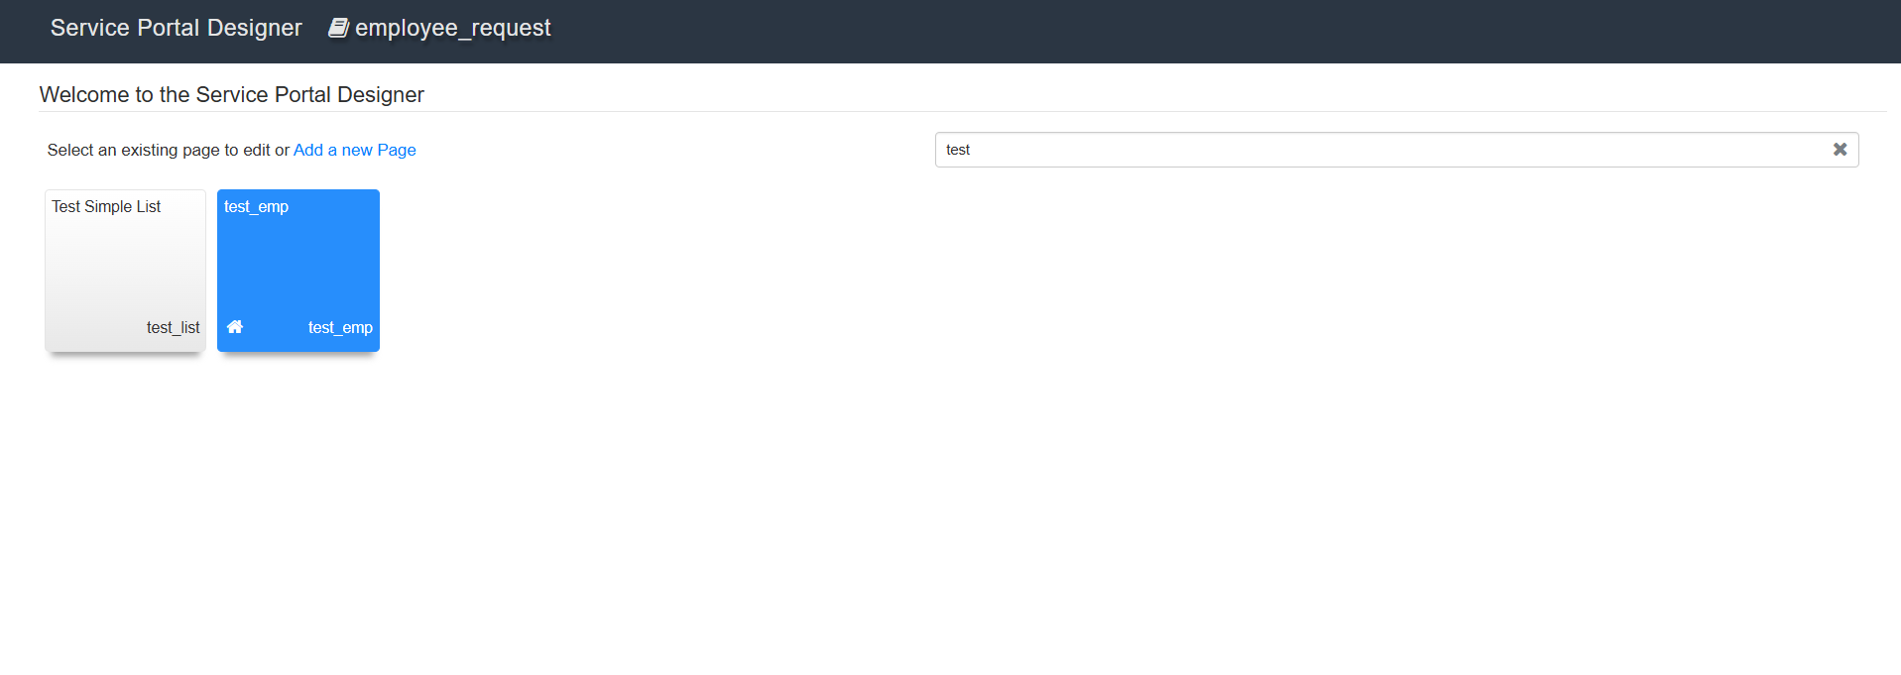
Widgets placed in the portal layout
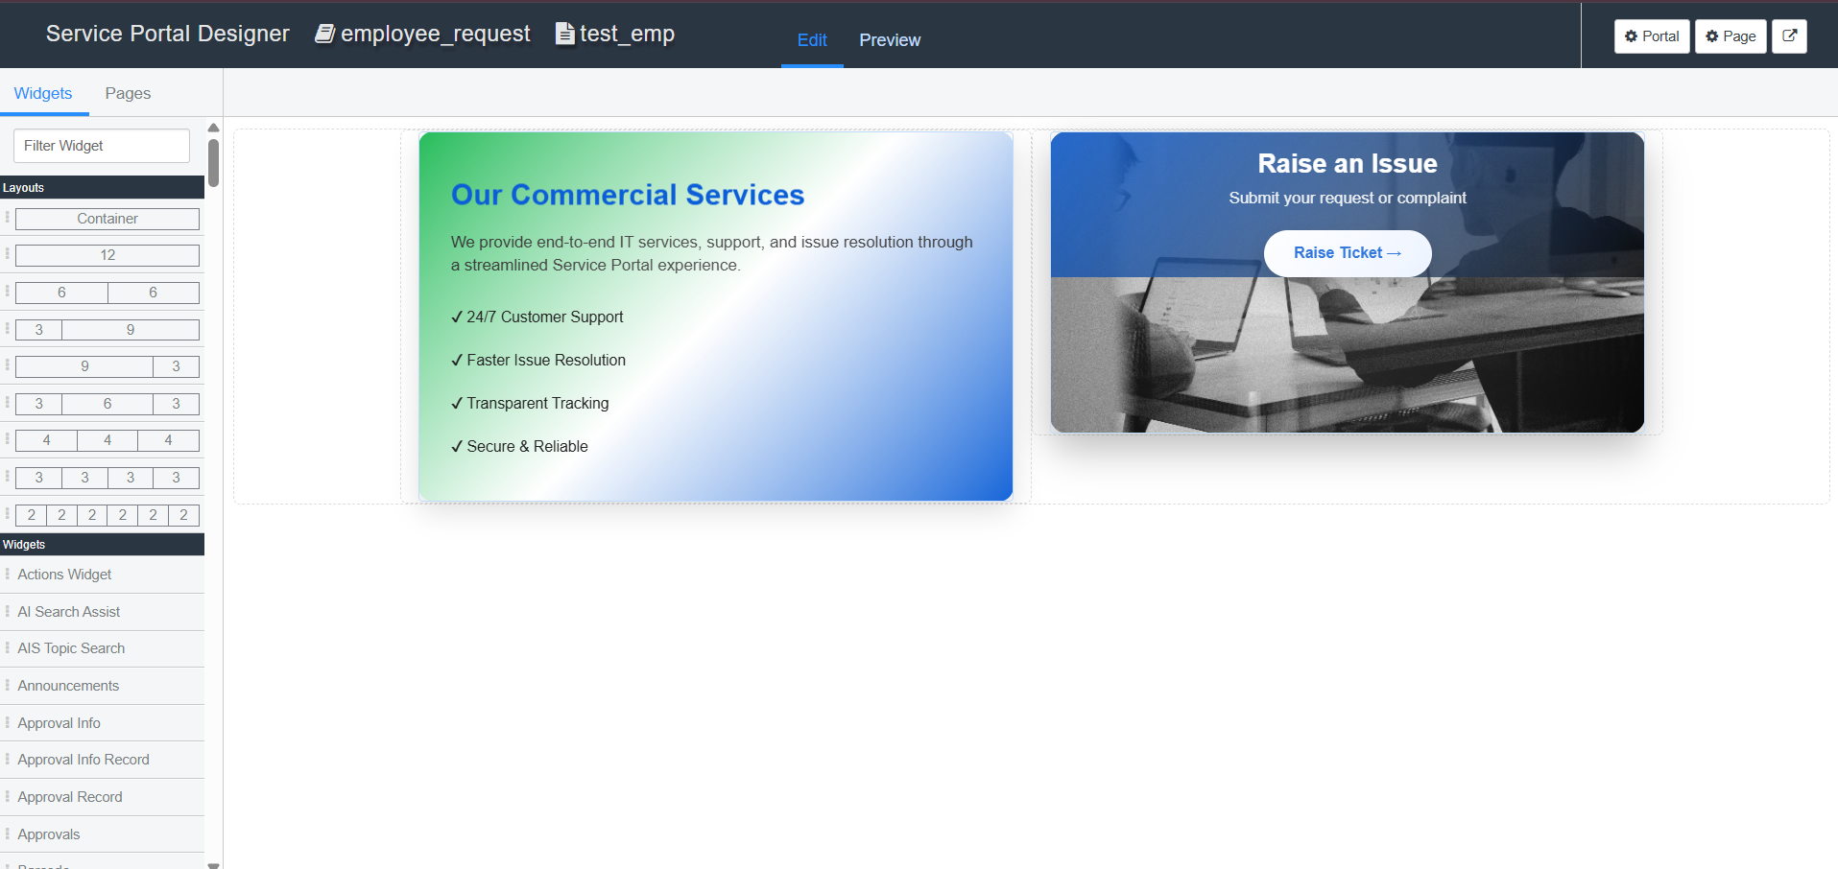

7. Result
The Commercial Widget was created and styled using HTML and CSS, and the required widgets were added to the Employee Center portal page.

